
CC-215-L: Database Systems Lab
Faculty of Computing & Information Technology

BS(IT&CS) Morning - Fall 2023
LAB – 09
The objective of this lab is to:
- Revise Previous Content
- Practice DML and DB Objects
Course & Lab Instructor: Dr. Asif Sohail
Task 01: [20 Marks]
*Uncheck the Autocommit checkbox in SQL commands window*
- Create a table emp_tab that shows the employee names, the name of their departments, their grades along with their manager's name. (Use of Join is not allowed)
CREATE TABLE emp_tab
(
ename VARCHAR2(20),
dname VARCHAR2(15),
grade NUMBER,
manager VARCHAR2(20)
);
commit;
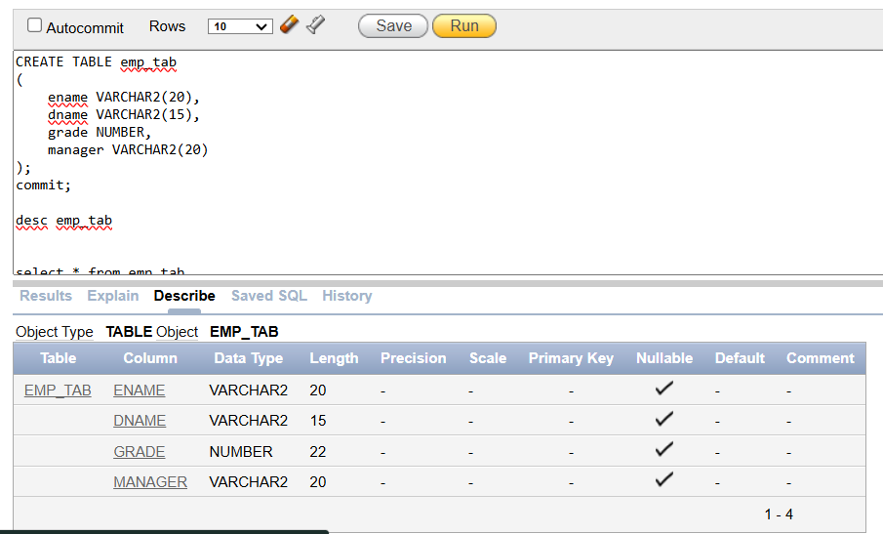
- Set the grades of all subordinates of a manager to zero if the manager supervises more than 3 employees.
Update emp_tab
set grade =0
where MANAGER IN
(select manager from emp_tab
group by manager
having count(*) > 3 );
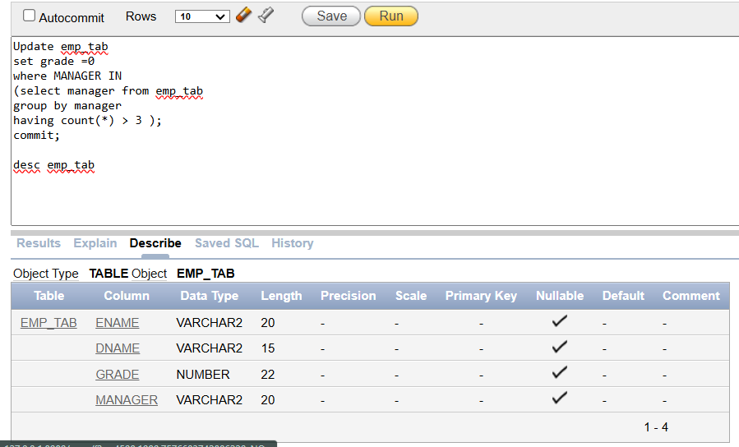
- Undo the previous action and delete the records of all subordinates of a manager, if that manager supervises more than 3 employees.
ROLLBACK;
COMMIT;
DELETE FROM EMP_TAB
WHERE MANAGER IN
(SELECT MANAGER FROM EMP_TAB
GROUP BY MANAGER
HAVING COUNT(*) > 3);
COMMIT;
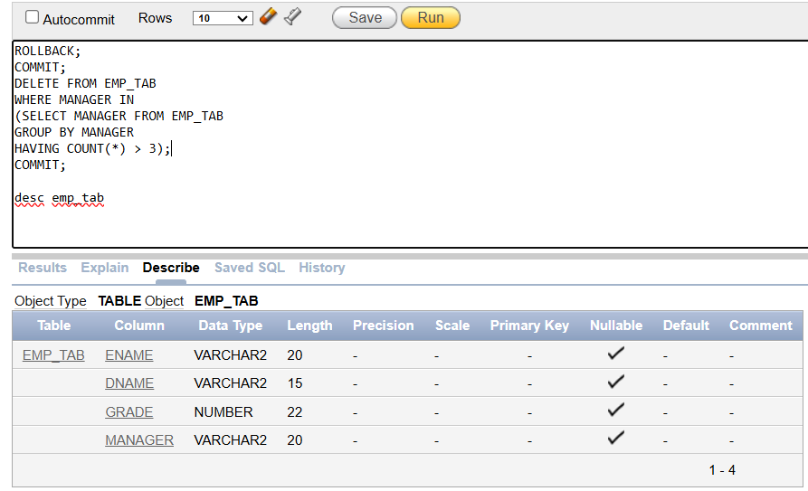
- Create an immutable view named sal_view that lists the three employees with the highest salary along with the three employees with the lowest salary in decreasing order. The following view should be created.
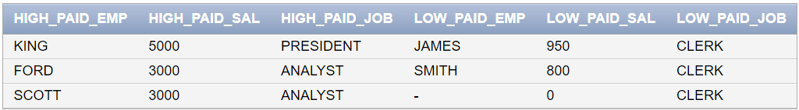
CREATE VIEW SAL_VIEW AS
SELECT ENAME HIGH_PAID_EMP,SAL HIGH_PAID_SAL,JOB HIGH_PAID_JOB
FROM EMP
WHERE SAL = (SELECT MAX(SAL) FROM EMP GROUP BY SAL)
UNION ALL
SELECT ENAME LOW_PAID_EMP,SAL LOW_PAID_SAL,JOB LOW_PAID_JOB
FROM EMP
WHERE SAL = (SELECT MIN(SAL) FROM EMP GROUP BY SAL)
- Alter the previously created view to include an additional column that displays the sum of the salaries of corresponding employees in the same row.

- Insert a new student with the next available roll number.
INSERT INTO STUDENT (ROLLNO,FIRSTNAME,LASTNAME,PHONENO)
VALUES (6 ,'New','Student','03234546656');
COMMIT;
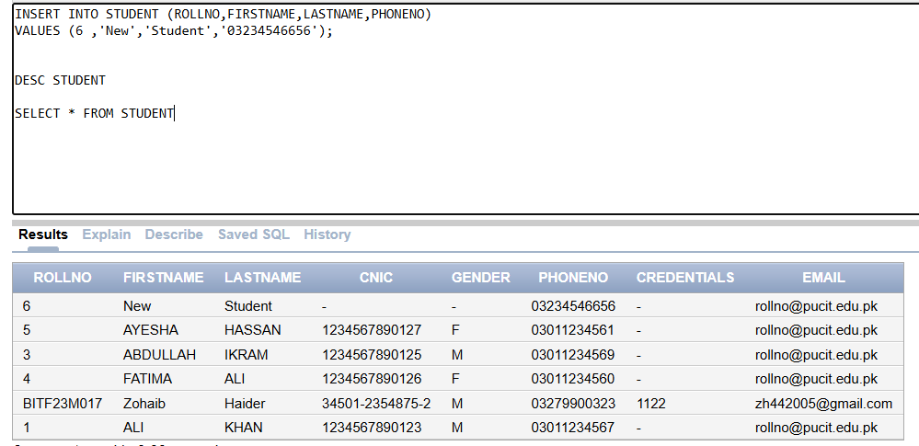

- Insert a teacher “Fareed ul Hassan” in the instructor table.
INSERT INTO INSTRUCTOR (REGNO,FIRSTNAME,QUALIFICATION)
VALUES (5,'FAREED UL HASSAN','PhD in SE');
commit;
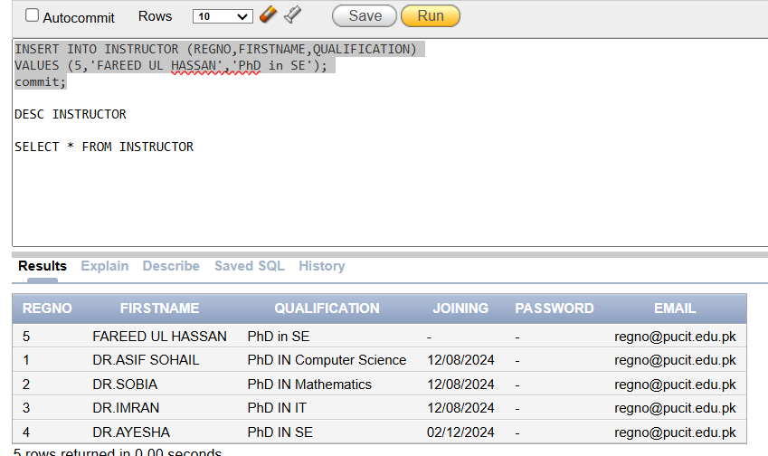
- Insert a new Course “Programming Fundamentals” in the Course table taught by “Fareed ul Hassan”.
INSERT INTO course (coursecode, coursetitle, instructorid)
VALUES ('CS105', 'Programming Fundamentals', (SELECT regno FROM instructor WHERE firstname LIKE 'FAREED UL HASSAN'));
commit;
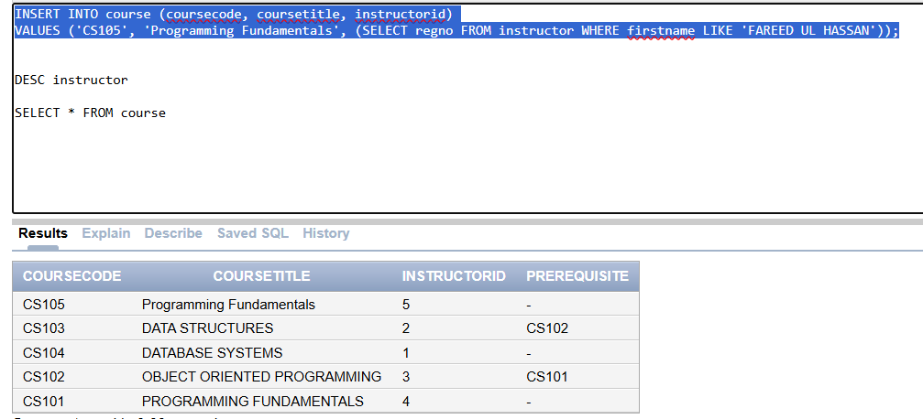
- Alter the constraint on Grade in Enrollment table. Add A- and B- grades as well. (You might have to Modify the table column too)
ALTER TABLE enrollment
ADD CONSTRAINT grade_check CHECK (grade IN ('A', 'B', 'C', 'D', 'F', 'A-', 'B-'));
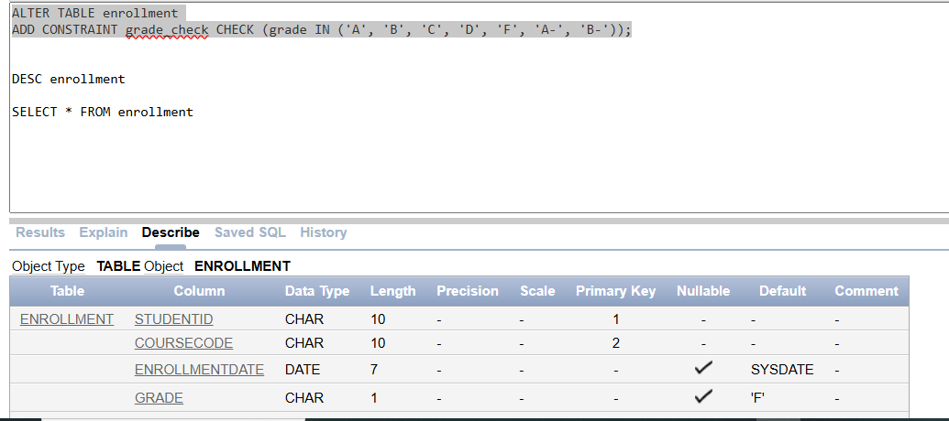
- Alter student table and allow NULL.
ALTER TABLE student
MODIFY firstname VARCHAR2(20) NULL;
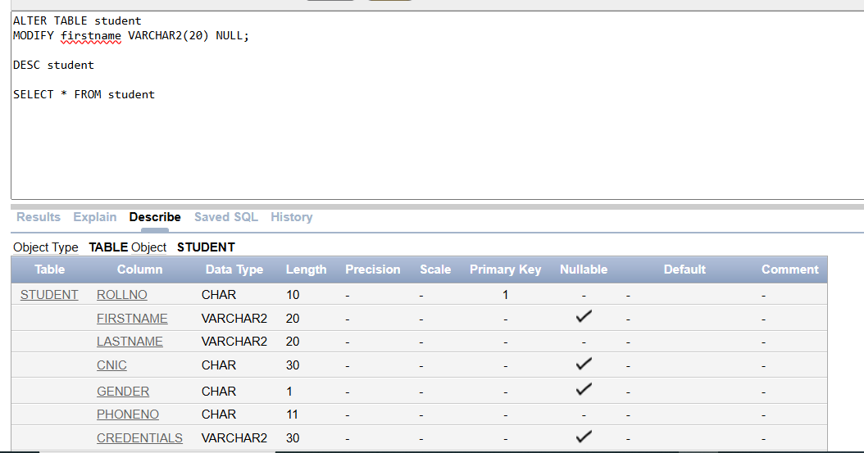
Task 02: [10 Marks]
- Create a new copy of the Employee table. Then, create a sequence for this table with the following specifications: an initial value equal to the maximum value of empno, incrementing by 1, a minimum value equal to the initial value, a maximum value of 10,000, a cache size of 10, and no cycle.
CREATE TABLE EMP_COPY AS
SELECT * FROM EMP;
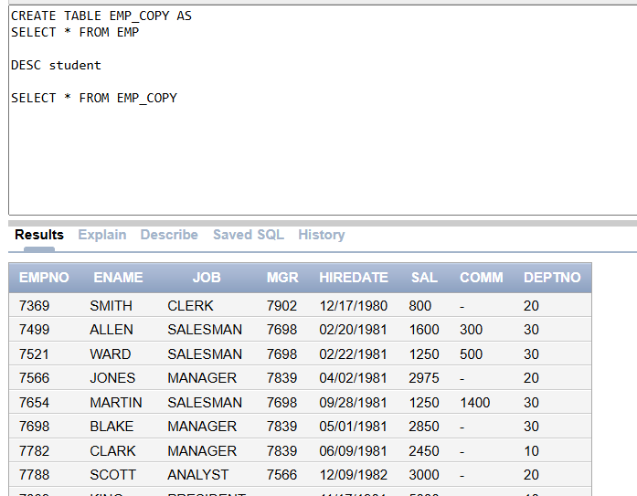
CREATE SEQUENCE emp_seq
START WITH 1
INCREMENT BY 1
MINVALUE 1
MAXVALUE 10000
CACHE 10
NOCYCLE;
- Insert a record into this table without explicitly entering the value of empno.
ENAME | JOB | HIREDATE | SAL | DEPTNO
JOHN | PAINTER | Current Date | 6000 | 20
INSERT INTO emp_copy (empno, ename, job, hiredate, sal, deptno)
VALUES (emp_seq.NEXTVAL, 'John', 'Painter', SYSDATE, 6000, 20);
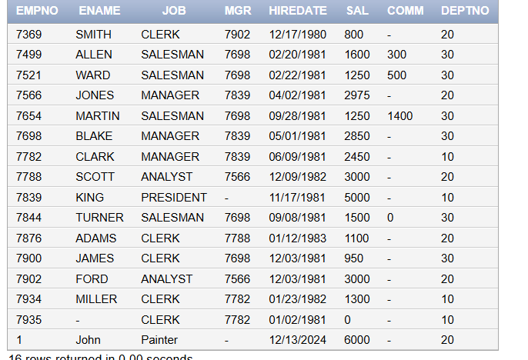
- Display the latest value of the sequence.
SELECT emp_seq.CURRVAL FROM dual;
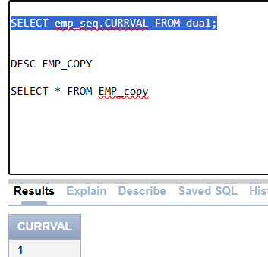
- Change the sequence to hold a maximum value of 999999 and an should be incremented by 10 after every insertion.
ALTER SEQUENCE emp_seq
MAXVALUE 999999
INCREMENT BY 10;
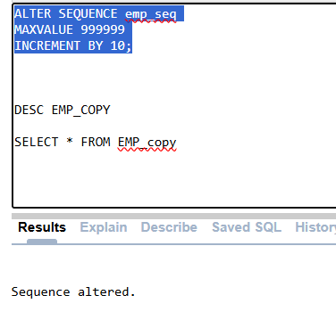
- Create a synonym named "emp_syn" for the employee copy table.
CREATE SYNONYM emp_syn FOR emp_copy;
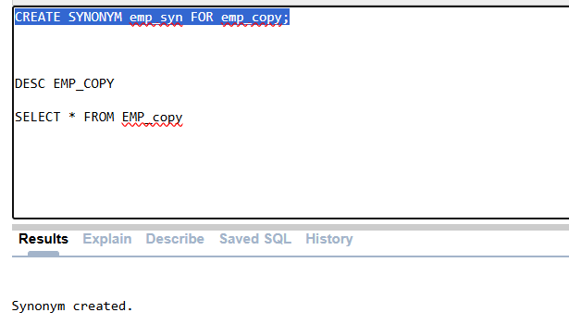
- Create a sequence for generating unique instructor registration numbers.
CREATE SEQUENCE instructor_seq
START WITH 1
INCREMENT BY 1
MINVALUE 1
MAXVALUE 10000
CACHE 10
NOCYCLE;
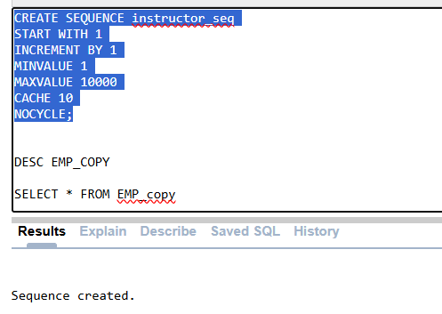
- Create an index on student IDs in attendance.
CREATE INDEX STU_IDX
ON ATTENDANCE(STUDENTID);
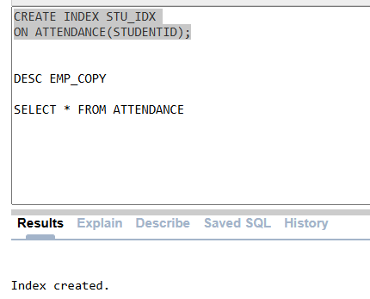
- Use the copy of employee table you created above and update the salary of each employee to the average salary of its department
UPDATE EMP_COPY
SET SAL = (SELECT AVG(SAL) FROM EMP GROUP BY DEPTNO HAVING EMP_COPY.DEPTNO=DEPTNO);
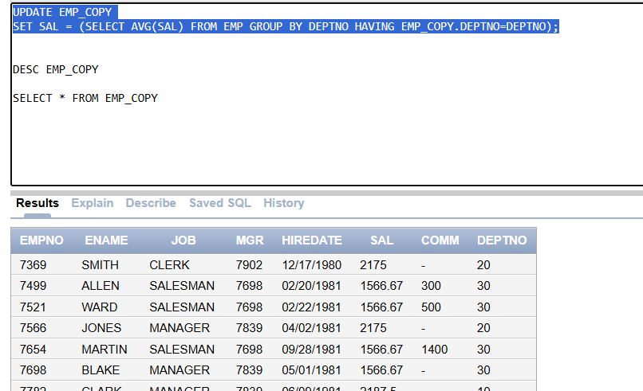
- Insert a new course “Object Oriented Programming” with prerequisite and instructor “Fareed ul Hassan”. You are not allowed to explicitly enter the IDs of Pre-requisite course and instructor.
INSERT INTO COURSE (COURSECODE,COURSETITLE,INSTRUCTORID,PREREQUISITE)
VALUES ('CS106','OOPS',(SELECT regno FROM instructor WHERE firstname LIKE 'FAREED UL HASSAN'),(SELECT COURSECODE FROM COURSE WHERE COURSETITLE LIKE 'OOPS'));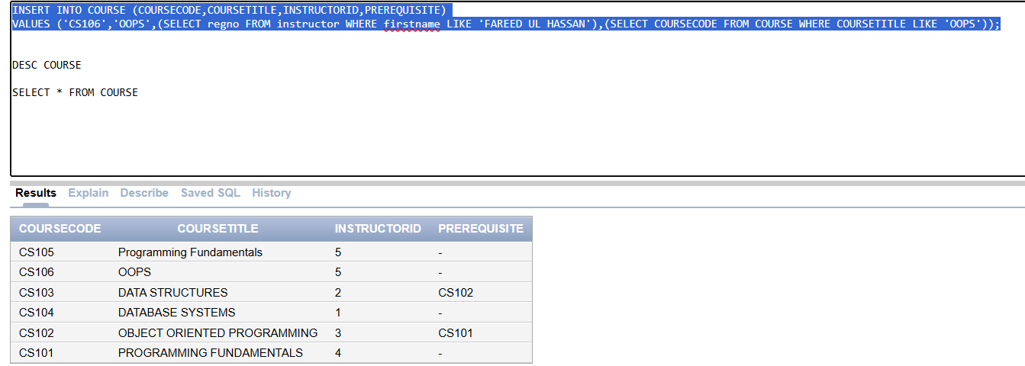
- Delete a course with no enrollments.
DELETE FROM COURSE
WHERE COURSECODE NOT IN (SELECT COURSECODE FROM ENROLLMENT);
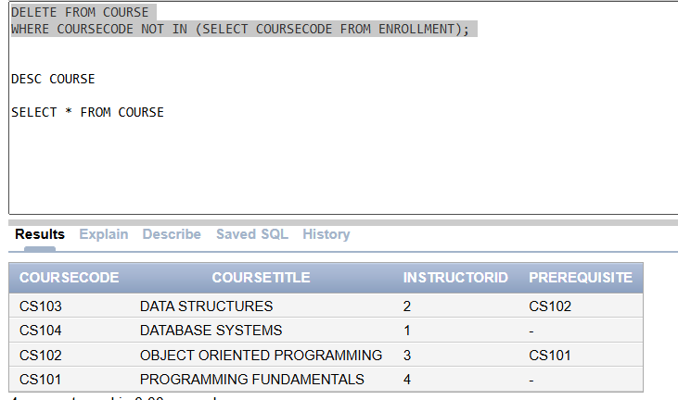
Task 04: [5 Marks]
VIVA VOCE

